Homework exercises must be prepared individually and submitted online through Brightspace prior to the posted deadline. Up to three submissions are allowed but only the last submission will be graded. See the Syllabus for more information on Homework Exercise requirements and expectations. Any necessary modifications to this assignment will be posted to Brightspace as an announcement.

For this exercise, submit only one Microsoft Word document with all appropriate output results and graphs from Minitab and Excel into the single Word document.

**Question 1**

*Fizzer Inc., a large, multinational pharmaceutical company, is developing a new product aimed at reducing the pain associated with migraine headaches and two drugs are currently under development. One consideration in the evaluation of the medication is how long the pain-killing effects of the drugs last. A random sample of 12 tests for each drug revealed the following times (in minutes) until the effects of the drug were neutralized. The random samples are as follows:*

|  |  |  |  |  |  |  |  |  |  |  |  |  |
| --- | --- | --- | --- | --- | --- | --- | --- | --- | --- | --- | --- | --- |
| Drug A | 258 | 214 | 243 | 227 | 235 | 222 | 240 | 245 | 245 | 234 | 243 | 211 |
| Drug B | 219 | 283 | 291 | 277 | 258 | 273 | 289 | 260 | 286 | 265 | 284 | 266 |

1. **Within Minitab, calculate the mean and standard deviation for each of the two drugs. (Hint: Minitab groups variables by columns. Have Drug A in one column and Drug B in another)**

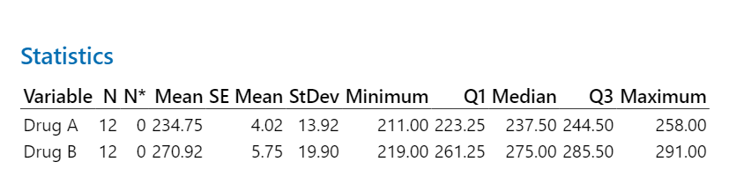

* Drug A:
  + Mean: 234.75
  + StDev: 13.92
* Drug B:
  + Mean: 270.92
  + StDev: 19.90

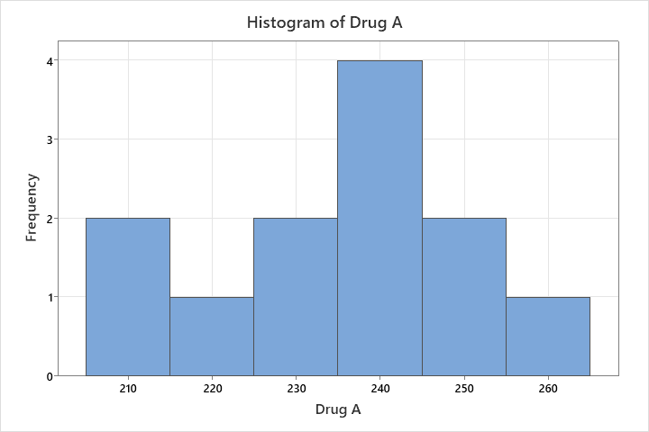

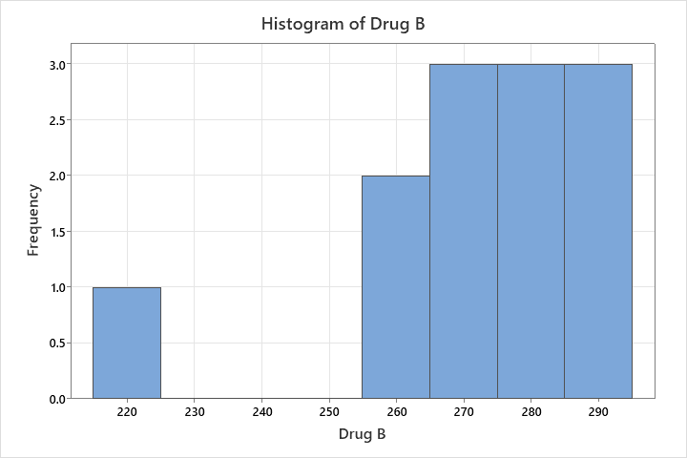

1. **Based on the sample means calculated in part a, which drug appears to be effective longer?**

* Drug B appears to be effective longer. This is based mean averages Drug A being 234.75 and Drug B being 270.92.

1. **Based on the sample standard deviations calculated in part a, which drug appears to have the greater variability in effect time?**

* Drug B has the greater Variability. This is due to Drug A having a Standard Deviation of 13.92 and Drug B having a Standard Deviation of 19.90

1. **Calculate the sample coefficient of variation for the two drugs. Based on the coefficient of variation, which drug has the greater variability in its time until the effect is neutralized? (Hint: check the Measures of Variability slide)**

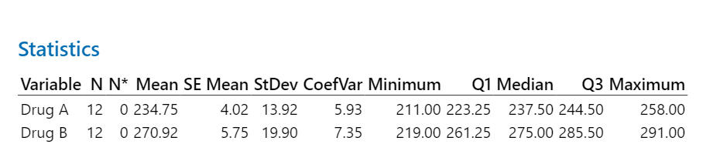

* Drug A:
  + CoefVar: 5.93 or 6%
* Drug B:
  + CoefVar: 7.35 or 7%
* Based on the coefficient of variation, Drug B shows a greater variability compared to Drug A. This is due to the Coefficient variable being a measure of relative variability and can be shown as a percentage. The higher the percentage the greater variability relative to the mean.

**Question 2**

*StockWatcher, an up and coming financial firm, tracks the performance of many companies and publishes an evaluation of each. Along with a variety of financial data, StockWatcher includes a Fair Value estimate for the price that should be paid for a share of the company’s common stock. Data for 30 companies are available in the file named “Fair_Value.xlsx”. The data include the Fair Value estimate per share of common stock, the most recent price per share, and the earning per share for the company.*

1. **Develop a scatter diagram for the Fair Value and Share Price data with Share Price on the horizontal axis. What is the sample correlation coefficient, and what can you say about the relationship between the variables?**

* Showing a high correlation coefficient with the relationship of Fair Value and Share Price shows a strong linear relationship between these two variables. It indicates that as Share Prices increase, the Fair Value also increases and the other way around.

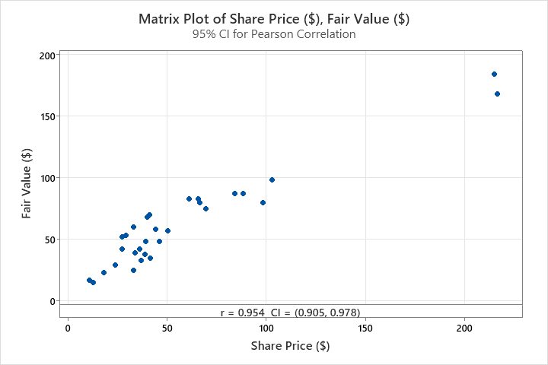

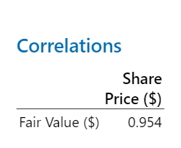

1. **Develop a scatter diagram for the Fair Value and Earnings per Share data with Earnings per Share on the horizontal axis. What is the sample correlation coefficient, and what can you say about the relationship between the variables?**

* The positive correlation coefficient shows a moderate linear relationship between Fair Value and Earnings per Share variables. This represents as Fair Trade increases Share Price shows a relationship that isn't as strong compared to Share Price and Fair Value.

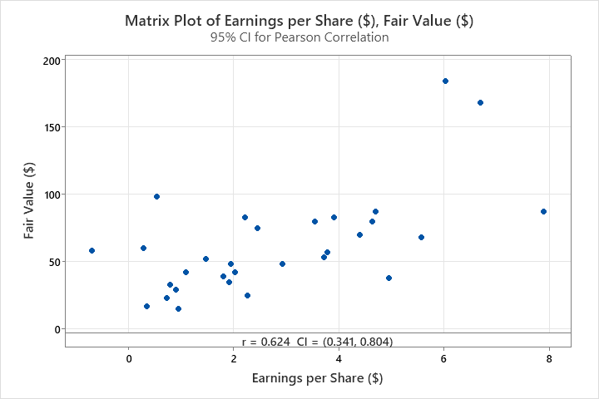

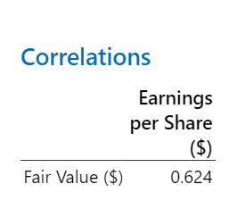

**Question 3**

*The Environmental Protection Agency (EPA) tests all new cars and provides a mileage rating for both city and highway driving conditions. Thirty cars were tested and are contained in the data file “Automobiles”. The file contains data on several variables. In this problem, focus on the city and highway mileage data.*

1. **Calculate the sample mean miles per gallon (mpg) for both city and highway driving for the 30 cars. Also, calculate the sample standard deviation for the two mileage variables. Does the data tend to support the premise that cars get better mileage on the highway than around town? Discuss.**

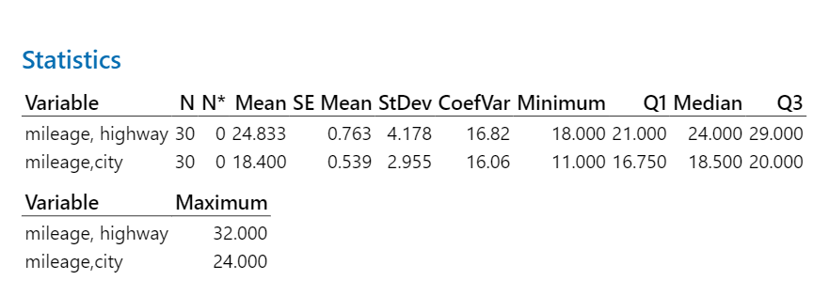

* Mileage, Highway:
  + Mean: 24.833
  + StDev: 4.178
* Millage, City:
  + Mean: 18.400
  + StDev: 2.955
  + This data set supports that cars generally get better mileage on the highway around town. This is due to the higher mean for Highway driving (24.83) compared to the City (18.4). The Highway holds a high standard deviation suggesting that there is greater variability in the Highway compared to the City.

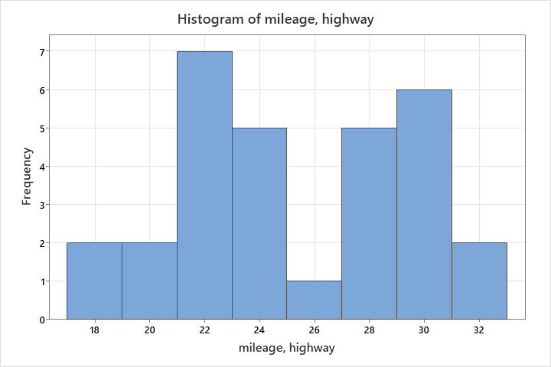

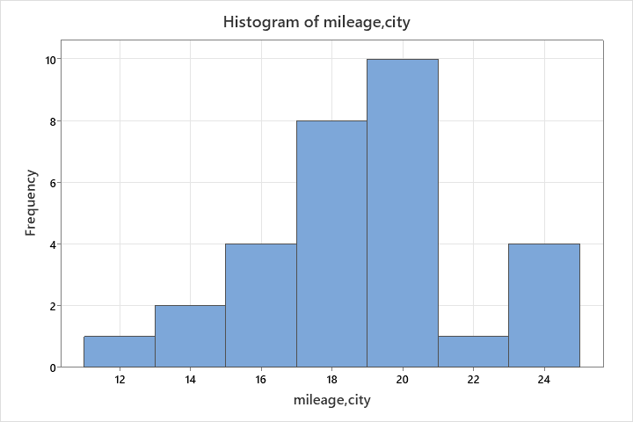

1. **Referring to part a, what can the EPA conclude about the relative variability between car models for highway versus city driving? (Hint: Compute the appropriate measure to compare relative variability.)**

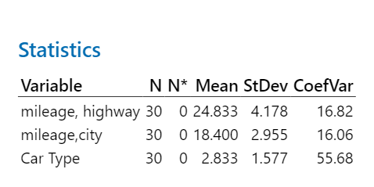

* Coefficient of Variation for Highway Mileage: 0.168
* Coefficient of Variation for City Mileage: 0.161

These Coefficients shown are close in value but Highway being slightly higher than City. The EPA can state that there is a similar level of relative variability in fuel efficiency between car models driving both Highway and City but a higher relative variability for Highway.

1. **Assume that mileage ratings are approximately bell-shaped. Approximately what proportion of cars gets at least as good mileage in city driving conditions as the mean mileage for highway driving for all cars?**

**- This was wrong is should have been 2.5%**

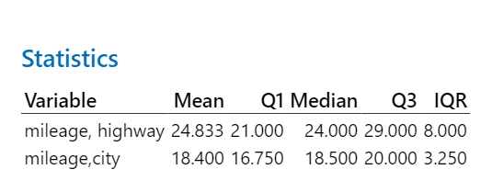

* The Mean highway mileage for all cars is 24.83 = 25 mileage
* Determining the proportion of City mileage per car compared to the Mean Highway Mileage is 0%

